|  |
| --- |
| **STUDENT NAME** |
| Replace this text with your full name |

**LAB #5**

ACTIVITY 1 2

ACTIVITY 2 10

ACTIVITY 3 12

ACTIVITY 4 16

# ACTIVITY 1

## DESIGNING A LOGO

A Logo is a symbol, that identifies your product, game, company etc. A well-designed logo can increase your product’s popularity and sales, catching the eye of the consumers.

Follow the steps below:

1. Double – click on the GIMP shortcut on your desktop.
2. Click File 🡪 New…
3. Set the Width and Height to 1920 and the Fill With option with Transparency.
4. Click OK.
5. Click Image 🡪 Guides 🡪 New Guide (By Percent).
6. Set the Horizontal selection to 50%.
7. Click Image 🡪 Guides 🡪 New Guide (By Percent).
8. Set the Vertical selection to 50%.
9. Click View 🡪 Snap to Image Edges.
10. Click on the Background color and select White.
11. Click on the Foreground color and select Black.
12. Click on the Ellipse tool and draw a circle in the middle of the image, as shown below:  
      
    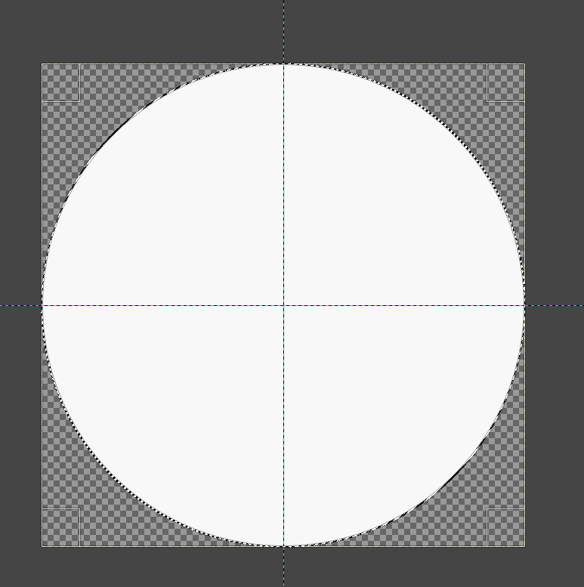
13. Click, Edit 🡪 Fill with BG Color.
14. Click Select None.
15. Under the Layers panel right-click 🡪 New Layer…
16. Name the new layer Layer2 and set the Fill With option with Transparency.
17. Click on the Ellipse tool and draw a circle in the new layer, starting from the center of the axes (click and hold the mouse button and then keep pressing Ctrl+Shift to set a circle center.).
18. Click Edit 🡪 Fill with Foreground Color.
19. The output should look like this:  
      
    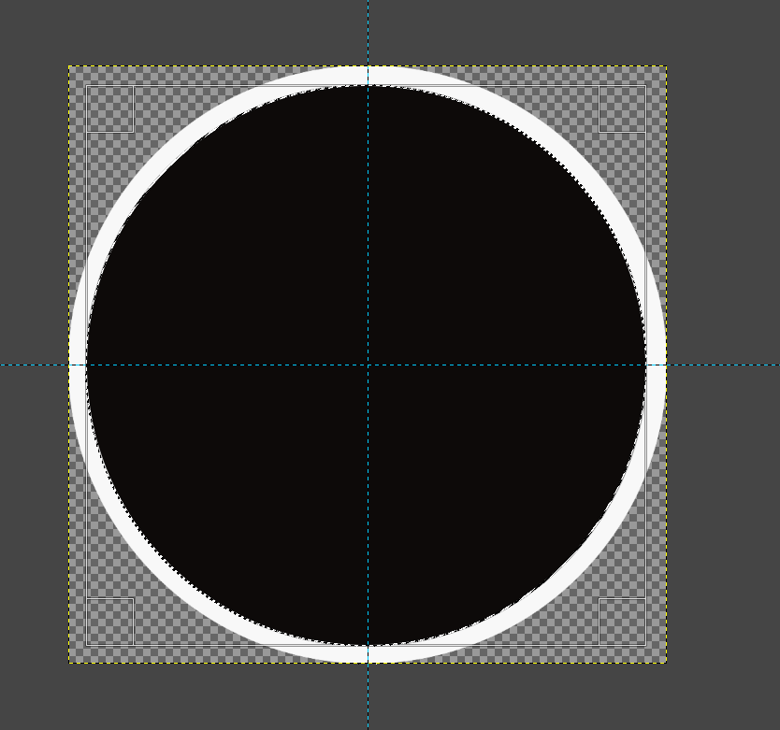
20. Under the Layers panel right-click 🡪 New Layer…
21. Name the new layer Layer3 and set the Fill With option with Transparency.
22. Click on the Ellipse tool and draw a circle in the new layer, starting from the center of the axes (click and hold the mouse button and then keep pressing Ctrl+Shift to set a circle center.).
23. Select a circle such as below:  
      
    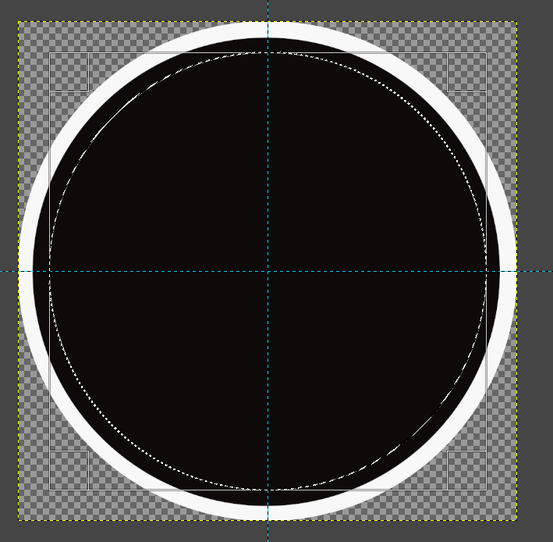
24. Click Edit 🡪 Stroke Selection.
25. Set the Line Width to 25 and press Stroke.

Once you complete the previous steps:

|  |
| --- |
| **TASK 1.1:**  Take a screenshot of your current progress and paste it below: |
|  |

1. Click Edit 🡪 None.
2. Under the Layers panel right-click 🡪 New Layer…
3. Name the new layer Layer4 and set the Fill With option with Transparency.
4. Click on the Rectangle tool and select and area as shown below:  
     
   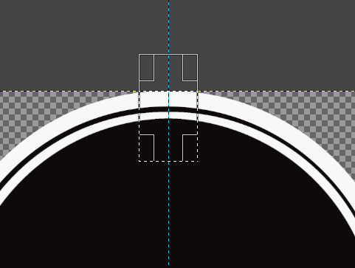
5. Click Edit 🡪 Fill with BG color (make sure that the BG color is black).
6. Make all the other layer invisible, clicking on the Eye button next to their names.
7. Click Select 🡪 None.
8. Click Layer 🡪 Crop to Content.
9. Click on the Alignment Tool and then select the rectangular area, as shown below:  
     
   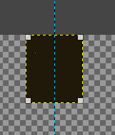
10. Click the Center under the alignment tool.
11. Under the Layers panel right-click 🡪 New Layer…
12. Name the new layer Layer5 and set the Fill With option with Transparency.
13. Pick the Rectangle Tool and draw a rectangle at the top left quarter of the guides.
14. Click Edit 🡪 Fill with FG color (white).
15. Click Select 🡪 None.
16. Click on the Move Tool and move it close to the center of the image.
17. Set the Opacity to 48 at the Layers panel.
18. Click on the Rotate tool and set an angle of 45.
19. Press Rotate.
20. Click on the Move tool and move the rectangle leftwards, as shown below:  
      
    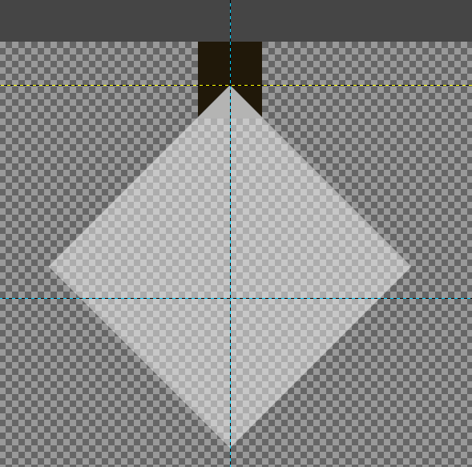
21. Click Layer 🡪 Crop to Content.
22. Click on the Scale Tool and the Move tool and set the size of the object as shown below:  
      
    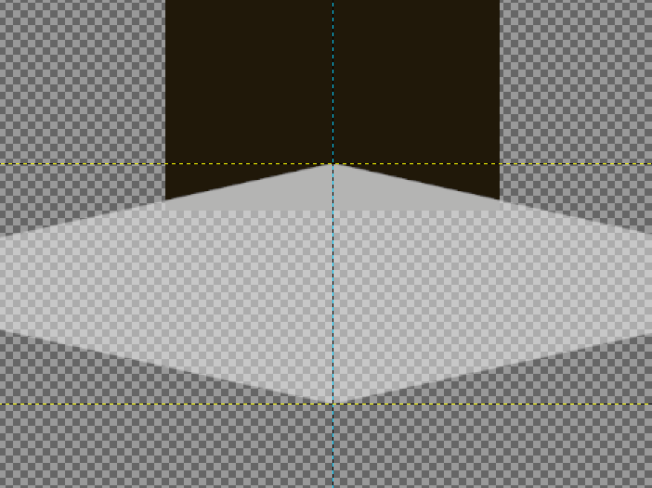
23. Right – click on Layer5 and select Alpha to Selection.
24. Right click on Layer 5 and select Delete this layer.
25. Press Delete (or Edit 🡪 Clear).
26. Click on all the Layer visibility icons and reveal them all.
27. Select Layer4, right – click 🡪 Duplicate.
28. Right – click 🡪 Alpha to Selection.
29. Edit 🡪 Fill with FG color (white).
30. Click Select 🡪 None.
31. Click Layer 🡪 Layer to Image size.
32. Click on the Scale tool.
33. Scale the selection as and place it over the previous layer.
34. Change its opacity to 35.
35. Move Layer4 at the top of the layers’ stack.
36. Set Layer5 Opacity to 100%.

|  |
| --- |
| **TASK 1.2:**  Take a screenshot of your current progress and paste it below: |
|  |

1. Pick the Paintbrush tool.
2. Select the Star Brush and draw a star inside the banner.
3. Move Layer4 over Layer5 and make the Layer5 fully Opaque.
4. Right – click on Layer4 and Merge Down.
5. Click Layer 🡪 Layer to Image Size.
6. Right – click on Layer5 and select Duplicate.
7. Click on the Flip Tool under the Tools.
8. Under the Flip Tool select Vertical.
9. Click on the star over Layer5.
10. Right – click on the Layer5 copy layer and select Merge Down.
11. Click on the Text tool under the Tools.
12. Pick a Font of you liking and select a White color for the letters.
13. Enlarge the text to fit the background image and center it.
14. Type the Logo of your game.
15. Click File 🡪 Export As…
16. Pick .png and export as Logo.png.

|  |
| --- |
| **TASK 1.3:**  Locate the Logo.png file and add it to the submission folder. |
| upload iconIn the LMS, add the file to the assignment Lab #5 submission folder. You can submit multiple files at a time. |

# ACTIVITY 2

## CHARACTER DESIGN TECHNIQUES

2D Characters could be from very simple sketches to complicates photorealistic animations. The purpose of the activity is to introduce you to basic character design demonstrating some simple techniques.

Follow the steps below:

1. Click File 🡪 New…
2. Set the dimensions to 1920x1920 and press OK.
3. Pick the Paintbrush tool, set its size to 5 and the FG color to Black.
4. Draw a character as shown below.  
     
   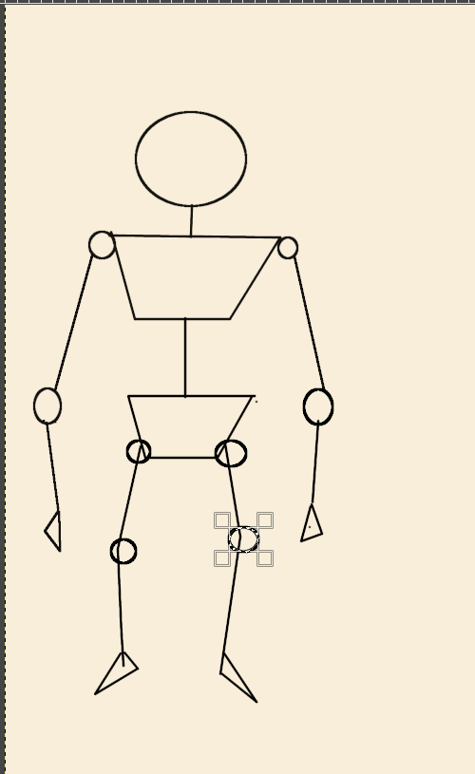
5. Select the Grey color and draw a few perpendicular lines as shown below, across all the length of the image.  
     
   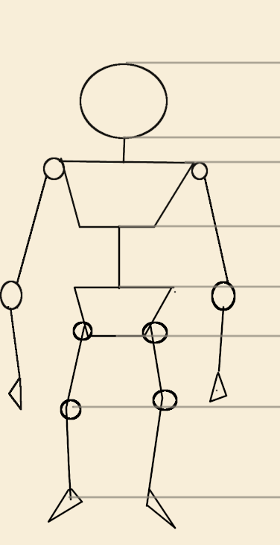
6. Draw the side of the same character keeping the same proportions.
7. Click File 🡪 Export as…
8. Export as SkeletonTutorial1.png

|  |
| --- |
| **TASK 2.1:**  Locate the SkeletonTutorial1.png file and add it to the submission folder. |
| upload iconIn the LMS, add the file to the assignment Lab #5 submission folder. You can submit multiple files at a time. |

# ACTIVITY 3

## SKETCHING WITH PROPORTIONS

Keeping the proportions of your characters is usually a good idea. An adult character will be 1.80m tall but a kid could be much shorter. It is not always easy to keep the proportions of the characters. An approach could be to i. set a grip, ii. create a background layer with a few of the basic shape to help us draw a character. This tutorial demonstrates how to draw a rough character under specific proportions and ask you to create other character cased on the first character.

Follow the steps below:

1. Click File 🡪 New…
2. Set the dimensions to 1920x1920 and press OK.
3. Click Image 🡪 Configure Grip.
4. Set the Spacing to 40 for Vertical and Horizontal.
5. Click OK.
6. Click View 🡪 Show Grid.
7. Name the current Layer Background.
8. Click on the Ellipse Select tool and draw a circle inside one of the squares of the grid.
9. Press Shirt and draw nine circles, always inside the grid and one under the other and two are the second line, as shown below:  
     
   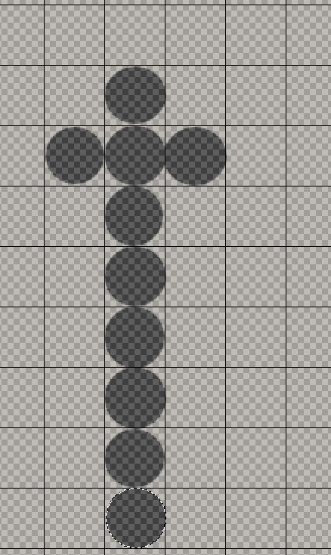
10. Right – click on the Layers panel and select Add New Layer.
11. Name the new Layer DrawingLayer and Set the Fill with option to **Transparency**.
12. Select the DrawingLayer layer.
13. Follow the consecutive step below and draw a rough human character sketch.
    1. 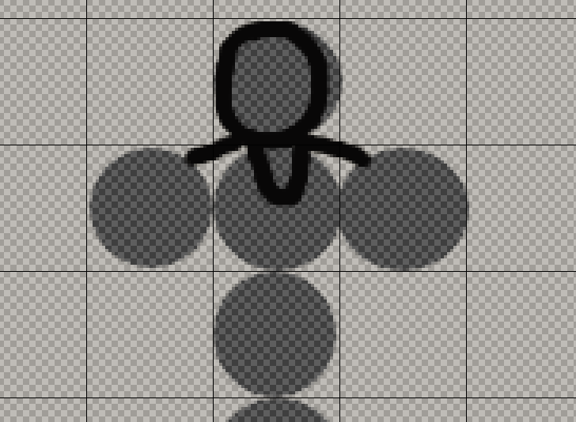
    2. 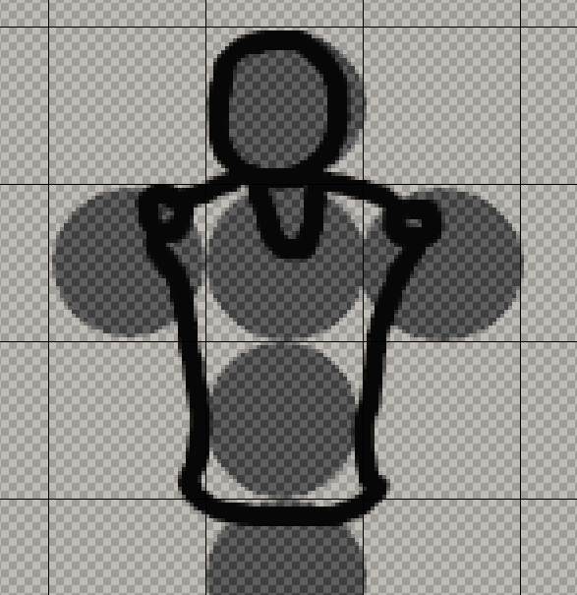
    3. 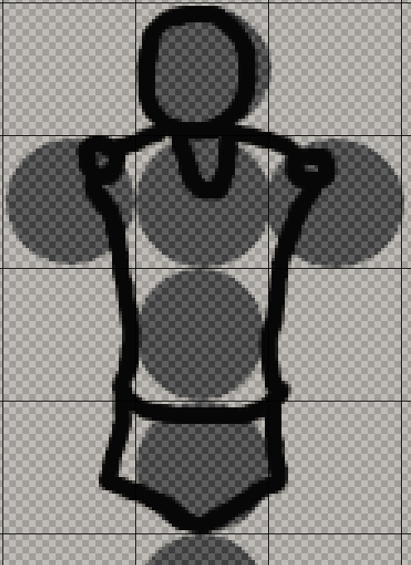
    4. 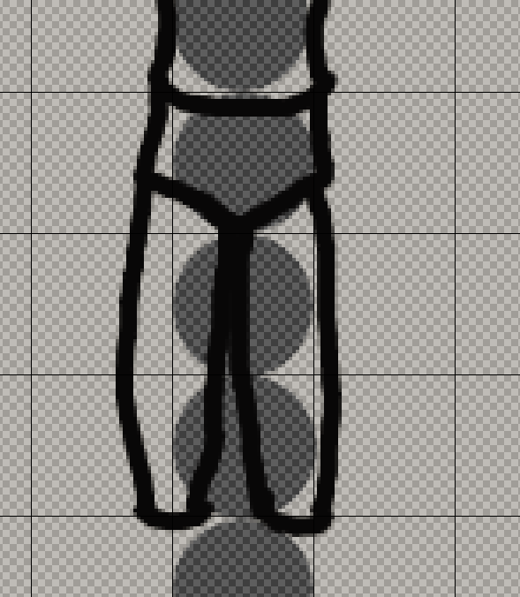
    5. 
    6. 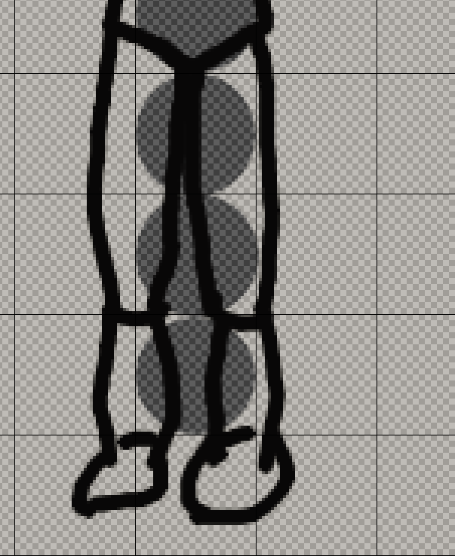
    7. 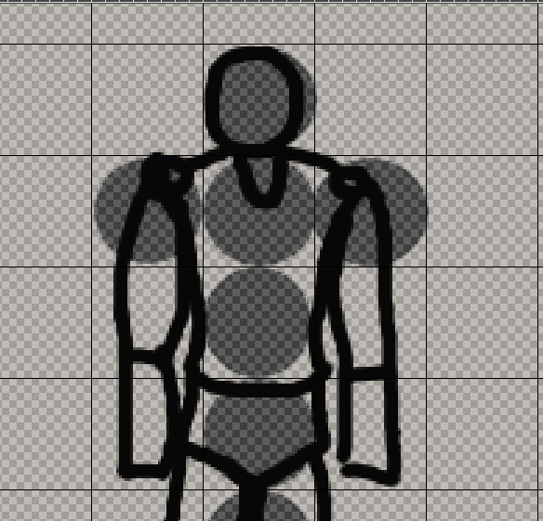

Once you complete the previous steps:

|  |
| --- |
| **TASK 3.1:**  Draw a teenager using 7 circles instead of nine, export the image as Teenager.png and add it to the submission folder. |
| upload iconIn the LMS, add the file to the assignment Lab #5 submission folder. You can submit multiple files at a time. |

|  |
| --- |
| **TASK 3.2:**  Draw a child using 5 circles instead of nine, export the image as Child.png png and add it to the submission folder. |
| upload iconIn the LMS, add the file to the assignment Lab #5 submission folder. You can submit multiple files at a time. |

|  |
| --- |
| **TASK 3.3:**  Draw a baby using 3 circles instead of nine, export the image as Baby.png and add it to the submission folder. |
| upload iconIn the LMS, add the file to the assignment Lab #5 submission folder. You can submit multiple files at a time. |

# ACTIVITY 4

## SKETCHING WITH PERPSECTIVE

A character made of straight perpendicular lines seems flat, unnatural and childish. A character should be designed with perspective in mind. This tutorial helps you to design character with curves, that enhance the dimensionality of your characters.

Follow the steps below:

1. Set the DrawingLayer layer, Opacity to 40.
2. Set the Background’s layer Opacity to 25.
3. Right – click on the layer’s panel 🡪 New Layer.
4. Name the new layer Perspective Layer.
5. Start drawing over the old chara`cter using curved lines, where appropriate to add a depth outlook, as shown below:  
     
   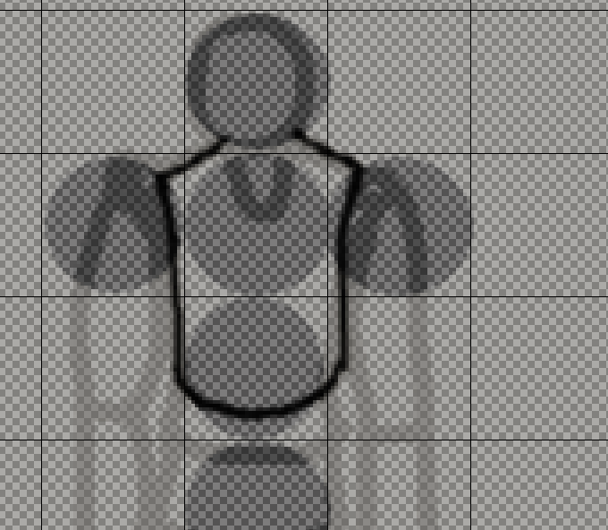  
     
   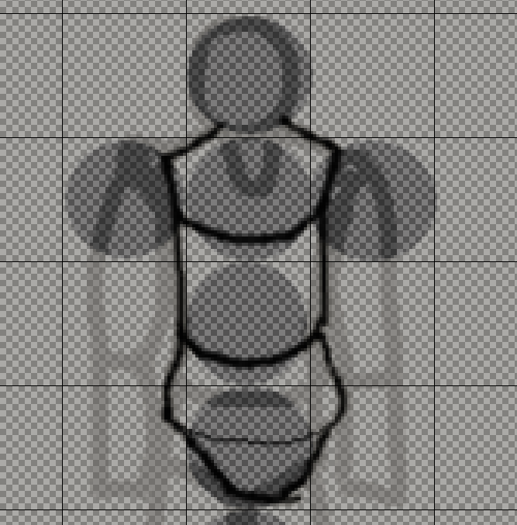

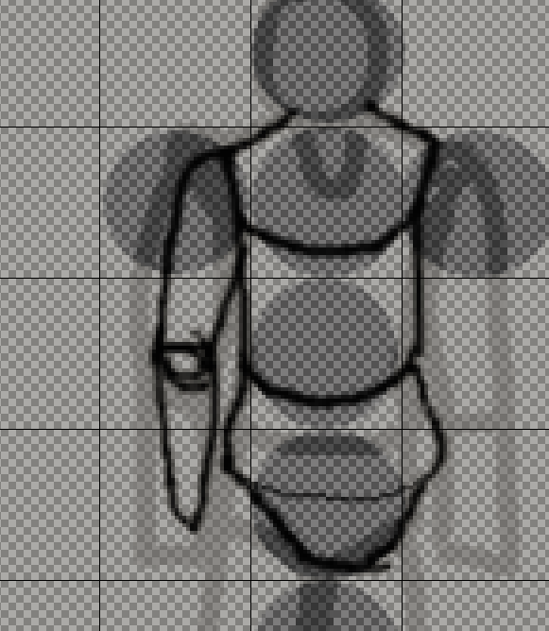

1. Select the right hand using the rectangle or the magic wand tool.
2. Click Edit 🡪 Copy and then Edit 🡪 Paste.
3. Under the toolbox click on the Flip tool.
4. Select Horizontal and click on the duplicated hand.
5. Click on the move button and adjust the hand, to fit the torso, erasing when needed.  
     
   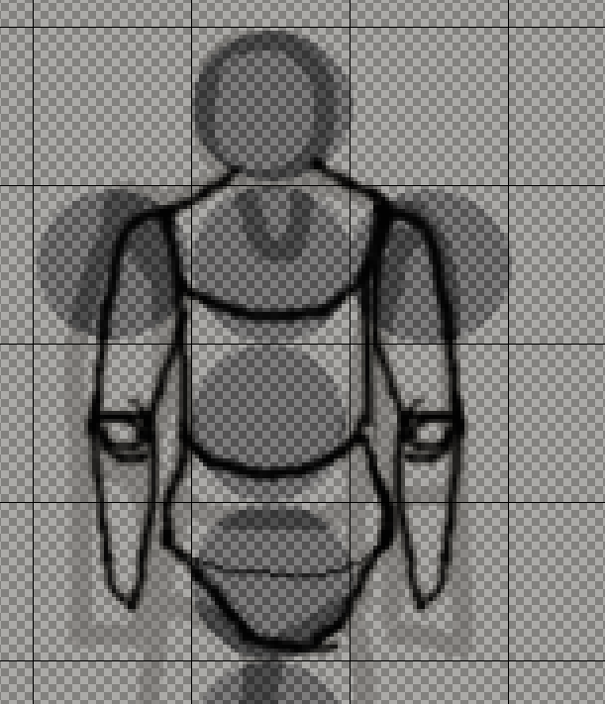

Once you complete the previous steps:

|  |
| --- |
| **TASK 4.1:**  Draw a right leg, duplicate, flip it and attach it to the body, then draw a head following a perspective shape, hide all the layer but the top, export as PerspectiveCharacter.png and add it to the submission folder. |
| upload iconIn the LMS, add the file to the assignment Lab #5 submission folder. You can submit multiple files at a time. |

FINAL STEP: Save this document as a PDF. Upload the PDF to the Lab #5 submission folder.